1 | What are the three major variations of Decrease and Conquer design strategy?
2 | Write the algorithm for Insertion Sort and derive its best and worst case time complexities. Explain Insertion Sort Algorithm with the following data  12, 6, 2, 5, 11, 4, 8, 1
2 | A priority queue is implemented as a Max Heap. Initially it has 5 elements. The level order traversal of heap is 11, 9, 6, 4 , 3. Two new elements 2 and 8 are inserted into the heap in that order. Find out the level order traversal of the heap after the insertion of elements.  Answer:  11, 9, 8, 4, 3, 2, 6
3 | Write an algorithm for max-heapify(A,i). Illustrate the operation of max-heapify(A,3) on the array A= 27, 17, 3, 16, 13, 10, 1 ,5 , 7,12,4, 8,9,0
4 | Write the algorithm to build a max heap. Describe your algorithm to build a max heap from the array A= 5, 7, 8, 2, 1, 0, 3, 9, 4, 5, 6 in a step by step process. Derive the time complexity of building max heap.
5 | Write an algorithm for the procedure heap-extract-max(A), where the procedure removes and returns the element of max-heap with largest key. Illustrate the operation of heap-extract-max on the heap A = 1, 3, 2, 6, 4, 5, 7, 8, 9
6 | Find the number of different topological orderings possible for the given graph-  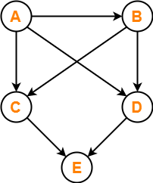
7 | Find the number of different topological orderings possible for the given graph-  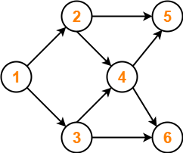
8 | Finishing the interiors of a lecture hall consists of several steps, such as laying electrical cables, installing audio-visual equipment, attaching the blackboard, etc. Suppose there are 10 steps, labelled A, B, C, D, E, F, G, H, I, J. Each step takes a day to complete and we have the following  A must happen before J  B must happen before D  B must happen before G  C must happen before B  D must happen before A  D must happen before E  E must happen before J  F must happen before C  G must happen before D  H must happen before F  H must happen before I  I must happen before B  I must happen before G  What is the minimum number of days required to complete the interiors?  Answer:8
9 | Given the following graph, which of the following orders are topological sorts (select all that apply)?  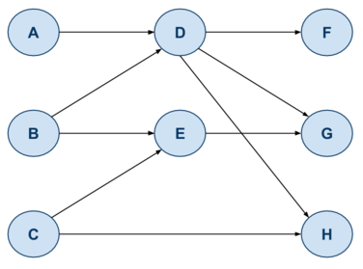  - A, D, H, F, G, E, B, C  C, B, E, A, D, H, F, G  A, B, C, E, D, H, G, F  C, A, B, E, D, F, G, H  B, A, D, C, H, E, G, F  A, B, D, F, C, E, G, H  B, A, D, F, C, G, H, E  A, B, C, D, E, F, G, H
10 | Give an algorithm for Topological Sort using DFS
11 | 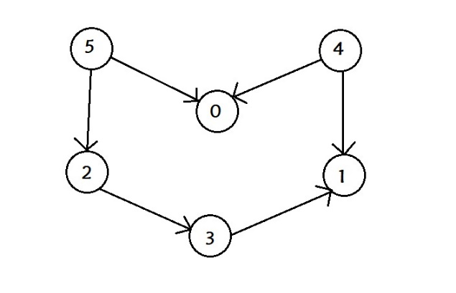  Apply Topological Sort to above graph

